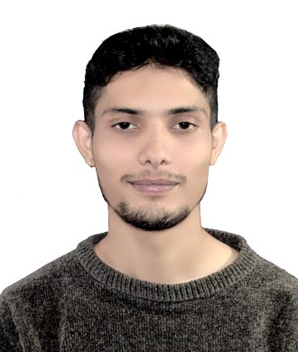

**Niroj Koirala**

**Panchakanya Height , Jamunapur , Ward no.12 , Ratnanagar , Chitwan , Nepal**

**Web Developer**

**About Me**

I am a Front-end developer since 2017 A.D. Web 3.0 research and self-study at home. Iam Full interested in front-end and back-end & more on. Java Script clock, Quick Quiz, Car-race & more are the example of my project. Recently, I work on Koji applicationcollaborated by metaverse.

**Professional Skills**

HTML / CSS / Java Script / React

**Working Experience**

Documentation Developer

Ireland, Dublin

**Extra- Curriculum**

Researching in Web 3.0 & Web 4.0

Researching in Meta Verse (Augmented Reality, Virtual Reality & Mixed Reality)

**Education**

ISMT second year Bsc.IT Naurange

NHSS Higher Level Computer Science Tadi

Unique Academy Primary/Secondary Level Tadi

**Contact**

Niroj [koirala@yahoo.com](mailto:koirala@yahoo.com) - Ymail

[Nirajkoirala11@gmail.com](mailto:Nirajkoirala11@gmail.com) - Gmail

9849446166 - Viber

9845819128 - Home